Blinkit sales Dashboard using Power BI
Project Overview
The Blinkit Sales Dashboard is an interactive Power BI project developed to analyze and visualize the Blinkit Sales dataset. It provides insights into sales performance, outlet characteristics, product categories, customer ratings, and item visibility through interactive charts. The dashboard helps transform raw data into meaningful insights for better business understanding and decision-making.
Dataset Description
The project uses the Blinkit Dashboard dataset available on Kaggle. The dataset contains product and outlet information used for sales analysis, including item type, item fat content, item visibility, sales, rating, outlet size, outlet location type, outlet type and outlet establishment year.
Dataset source: Kaggle – Blinkit Dashboard: https://www.kaggle.com/datasets/architgoel29/blinkit-dashboard
Data Preparation
The data was prepared in Power Query before creating the dashboard. The main cleaning activities included:
Checking and setting appropriate data types for numeric, text and year fields.
Standardising Item Fat Content values so that variations such as LF/low fat and reg/Regular are treated consistently.
Checking missing values in fields such as Item Weight.
Checking zero values in Item Visibility and handling values that do not represent meaningful visibility.
Removing duplicate records using the product and outlet identifiers.
Renaming and standardising column names for easier use in Power BI.
Dashboard Visualizations
The report is organised into three pages so that the main dashboard remains clear while detailed and advanced analysis is kept on separate pages.
Page 1 – Executive Sales Dashboard
This page focuses on overall business performance.
Sales by Outlet Type – Clustered Bar Chart
Sales by Item Type – Horizontal Bar Chart
Sales by Outlet Size – Donut Chart
Sales by Outlet Location Type – Column Chart
Outlet Establishment Year vs Sales – Line Chart
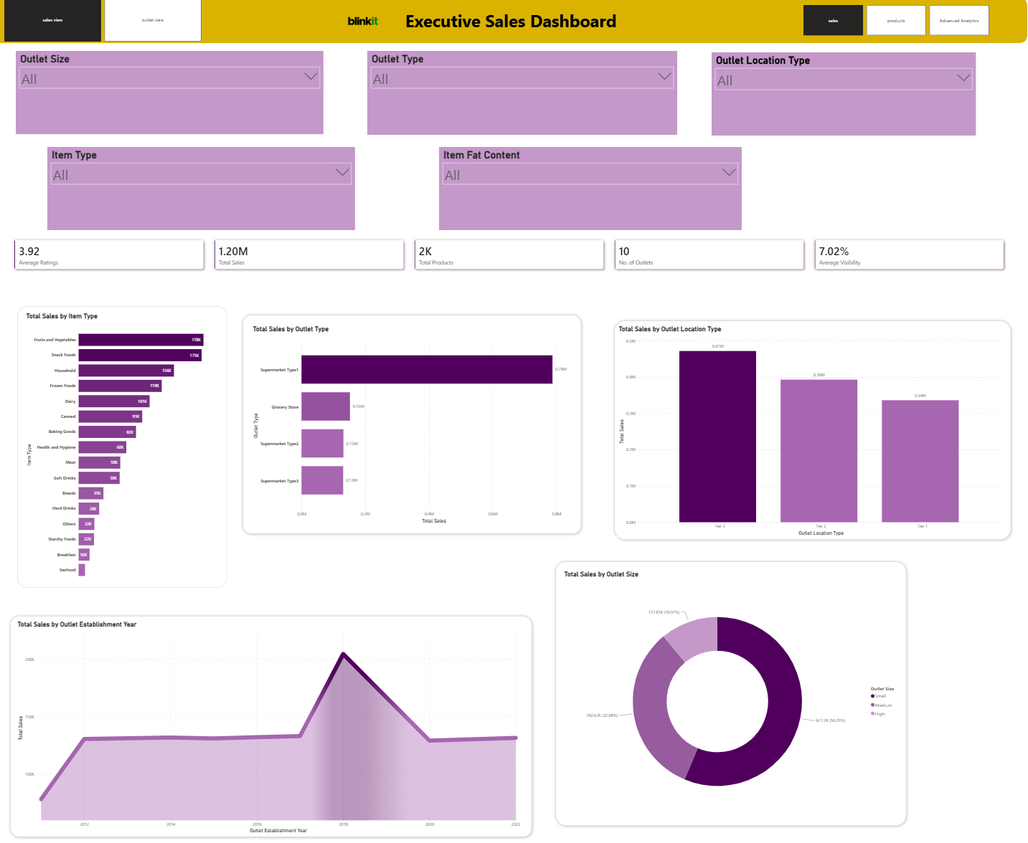
Page 2 – Product Insights
This page focuses on product performance and customer-related analysis.
Item Visibility vs Sales – Scatter Plot, with Outlet Type used as the legend.
Average Rating by Item Type – Column Chart.
Total Sales by Item Fat Content and Outlet Location Type – Donut Chart.
Average Rating by Item Type and Outlet Location Type – comparative rating visual.
Some overlapping visuals from the original reference were removed to avoid repeating the same information and to keep the page easier to read.
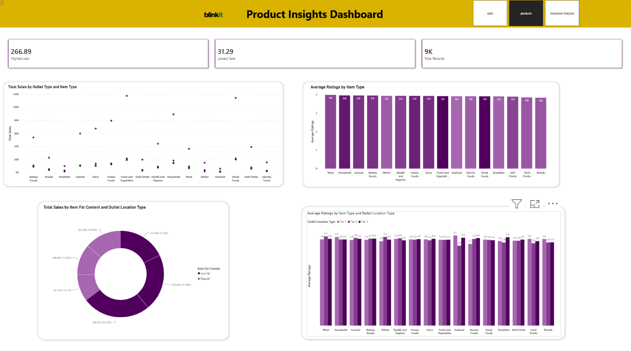
Page 3 – Advanced Analytics
This page demonstrates Power BI visuals that support deeper analysis.
Total Sales by Item Type – Waterfall Chart.
Sales and rating details – Matrix.
Total Sales – Decomposition Tree, allowing the sales figure to be explored through outlet type, outlet size, outlet location type and item type. 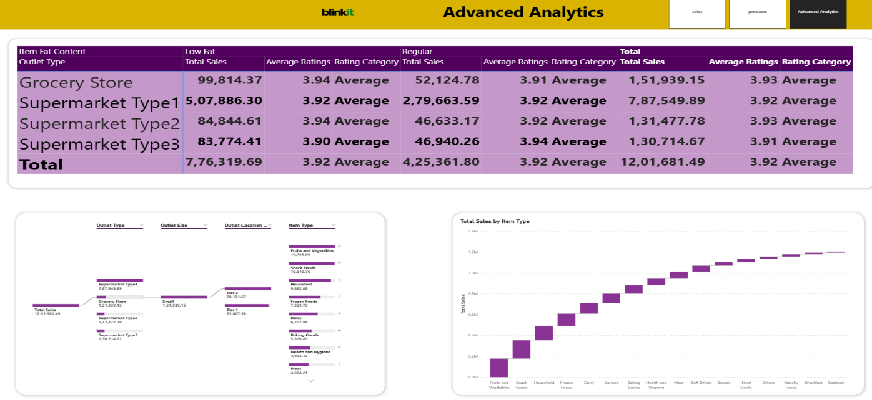

Key Measures
The dashboard uses measures to calculate the main KPIs and analysis values. Examples include:
Total Sales = SUM of Sales
Average Rating = AVERAGE of Rating
Total Products = DISTINCTCOUNT of Item Identifier
Number of Outlets = DISTINCTCOUNT of Outlet Identifier
Average Item Visibility = AVERAGE of Item Visibility
Highest sales = MAX of sales
Lowest Sales = MIN of sales
Total Records = COUNTROWS of dataset
Conclusion
The Blinkit Sales Dashboard effectively presents sales data through interactive visualizations. It enables users to explore sales performance, outlet characteristics, and product-related insights in a simple and meaningful way. The three-page structure separates overall business performance, product insights, and advanced analytics, making the dashboard easier to navigate and understand. This project demonstrates how Power BI can be used to transform business data into informative dashboards that support analysis and better decision-making.
Tools Used
- Microsoft Power BI

